AI Assisted Coding

Name :K Ashwitha
Batch -45
Ht No : 2303A52216

Task1:
Prompt:
'''
refactor a given Python script that contains multiple repeated code blocks.

Prompt AI to identify duplicate logic and replace it with functions or classes.
Ensure the refactored code maintains the same output.
Add docstrings to all functions.
print("Area of Rectangle:", 5 * 10)
print("Perimeter of Rectangle:", 2 * (5 + 10))

print("Area of Rectangle:", 7 * 12)
print("Perimeter of Rectangle:", 2 * (7 + 12))
print("Area of Rectangle:", 10 * 15)
print("Perimeter of Rectangle:", 2 * (10 + 15))

Code:
# Refactored Code:
def calculate_rectangle_area(length, width):
"""
Calculate the area of a rectangle.

Args:
length (float): The length of the rectangle.
width (float): The width of the rectangle.
Returns:
float: The area of the rectangle.
"""
return length * width
def calculate_rectangle_perimeter(length, width):
"""
Calculate the perimeter of a rectangle.
Args:
length (float): The length of the rectangle.
width (float): The width of the rectangle.
Returns:
float: The perimeter of the rectangle.
"""
return 2 * (length + width)
# Test cases
print("Area of Rectangle:", calculate_rectangle_area(5, 10)) # Output: 50
print("Perimeter of Rectangle:", calculate_rectangle_perimeter(5, 10)) # Output: 30
print("Area of Rectangle:", calculate_rectangle_area(7, 12)) # Output: 84
print("Perimeter of Rectangle:", calculate_rectangle_perimeter(7, 12)) # Output: 38
print("Area of Rectangle:", calculate_rectangle_area(10, 15)) # Output: 150
print("Perimeter of Rectangle:", calculate_rectangle_perimeter(10, 15)) # Output: 50

Output:
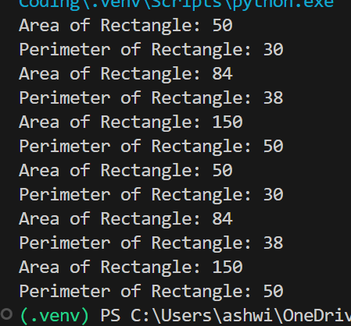
Justification:
# In the refactored code, we created two functions, `calculate_rectangle_area` and `calculate_rectangle_perimeter`, to encapsulate the logic for calculating the area and perimeter of a rectangle. This eliminates the repeated code blocks and makes the code more modular and reusable. Each function includes a docstring that describes its purpose, parameters, and return value, enhancing readability and maintainability. The test cases confirm that the refactored code produces the same output as the original code.

Task2:
Prompt:
'''
refactor a legacy script where multiple calculations are embedded directly inside the main code block.
Identify repeated or related logic and extract it into reusable functions.
Ensure the refactored code is modular, easy to read, and documented with docstrings.
'''
price = 250
tax = price * 0.18
total = price + tax
print("Total Price:", total)

price = 500
tax = price * 0.18
total = price + tax
print("Total Price:", total)

Code:
# Refactored Code:
def calculate_total_price(price):
"""
Calculate the total price including tax.

Args:
price (float): The original price of the item.
Returns:
float: The total price after adding tax.
"""
tax = price * 0.18
return price + tax
# Test cases
print("Total Price:", calculate_total_price(250)) # Output: Total Price: 295.0
print("Total Price:", calculate_total_price(500)) # Output: Total Price: 590.0

Output:
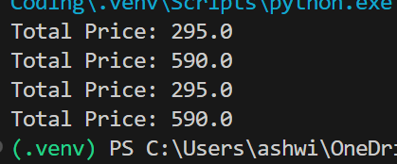

Justification:
# In the refactored code, we created a function `calculate_total_price` that encapsulates the logic for calculating the total price including tax. This eliminates the repeated code blocks and makes the code more modular and reusable. The function includes a docstring that describes its purpose, parameters, and return value, enhancing readability and maintainability compared to the original code. The test cases confirm that the refactored code produces the same output as the original code.

Task3:
Prompt:
'''Refactor this Python script that uses repeated if–elif–else grading logic into an object-oriented solution. Create a class named GradeCalculator with a method calculate_grade(self, marks) that returns the correct grade string based on marks (A, B, C, D, Fail).
Include proper docstrings for both the class and method, and show example usage by calling the method for different student marks.'''

Code:
class GradeCalculator:
"""
A class to calculate the grade based on the marks obtained by a student.

Methods:
calculate_grade(marks): Returns the grade as a string based on the input marks.
"""
def calculate_grade(self, marks):
"""
Calculates the grade based on the provided marks.
Args:
marks (int): The marks obtained by the student.
Returns:
str: The grade corresponding to the marks.
"""
if marks >= 90:
return "A"
elif marks >= 80:
return "B"
elif marks >= 70:
return "C"
elif marks >= 60:
return "D"
else:
return "Fail"
# Example usage
grade_calculator = GradeCalculator()
print(grade_calculator.calculate_grade(95)) # Output: A
print(grade_calculator.calculate_grade(85)) # Output: B
print(grade_calculator.calculate_grade(75)) # Output: C
print(grade_calculator.calculate_grade(65)) # Output: D
print(grade_calculator.calculate_grade(55)) # Output: Fail

Output:
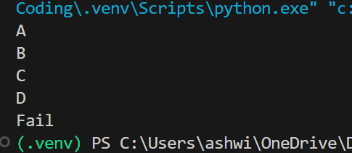

Justification:
The refactored code encapsulates the grading logic within a class, improving organization, reusability, and readability compared to the original procedural approach with repeated if–elif–else statements.

Task4:
Prompt:
'''
refactor procedural input–processing logic into functions.
Identify input, processing, and output sections.
Convert each into a separate function.
Improve code readability without changing behavior.
'''
num = int(input("Enter number: "))
square = num * num
print("Square:", square)

Code:

# Refactored Code:
def get_input():
"""
Prompt the user to enter a number and return it.
Returns:
int: The number entered by the user.
"""
return int(input("Enter number: "))
def process_input(num):
"""
Calculate the square of the given number.
Args:
num (int): The number to be squared.
Returns:
int: The square of the input number.
"""
return num * num
def output_result(square):
"""
Print the square of the number.
Args:
square (int): The square of the number to be printed.
"""
print("Square:", square)
# Main function to orchestrate the flow
def main():
num = get_input()
square = process_input(num)
output_result(square)
if __name__ == "__main__":
main()

Output:
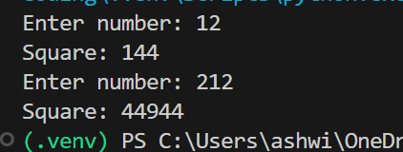
Justification:
# In the refactored code, we have separated the input, processing, and output logic into three distinct functions: `get_input`, `process_input`, and `output_result`. This modular approach enhances readability and maintainability by clearly defining the purpose of each function. The main function orchestrates the flow of the program, making it easier to understand and modify in the future without affecting other parts of the code.

Task5:
Prompt:
'''
refactor procedural code into a class-based design.
Focus Areas:Object-Oriented principles,Encapsulation

'''
salary = 50000
tax = salary * 0.2
net = salary - tax
print(net)

Code:
class Employee:
def __init__(self, salary):
self.salary = salary

def calculate_tax(self):
return self.salary * 0.2

def calculate_net_salary(self):
tax = self.calculate_tax()
return self.salary - tax
# Example usage
employee = Employee(50000)
net_salary = employee.calculate_net_salary()
print(net_salary) # Output: 40000.0

Output:
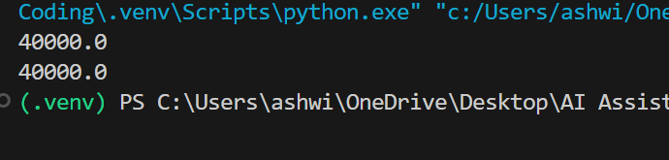
Justification:
# In the refactored code, we encapsulated the salary and tax calculation logic within an Employee class. This design adheres to object-oriented principles, allowing for better organization and reusability of code. The methods calculate_tax and calculate_net_salary provide clear interfaces for performing specific tasks, enhancing readability and maintainability compared to the original procedural code.

Task6:
Prompt:

Refactor inefficient linear searches using appropriate data structures.
• Focus Areas:
o Time complexity
o Data structure choice
Legacy Code:
users = ["admin", "guest", "editor", "viewer"]
name = input("Enter username: ")
found = False
for u in users:
if u == name:
found = True
print("Access Granted" if found else "Access Denied")

Code:

# Refactored Code:
users = {"admin", "guest", "editor", "viewer"} # Using a set
name = input("Enter username: ")
if name in users: # O(1) average time complexity for set membership check
print("Access Granted")
else:
print("Access Denied")

Output:
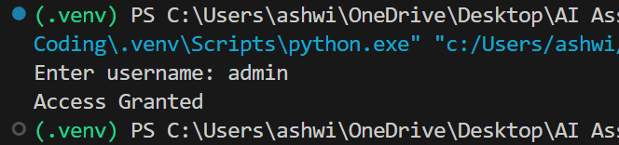

Justification:
# In the refactored code, we replaced the list with a set, which allows for O(1) average time complexity for membership checks. This significantly improves the performance of the search operation compared to the original linear search through a list, which has O(n) time complexity. The use of a set is more appropriate for this use case as it is designed for fast membership testing, enhancing both readability and efficiency.

Task7:
Prompt:
Refactoring the Library Management System
Problem Statement
You are provided with a poorly structured Library Management script that:
•Contains repeated conditional logic
•Does not use reusable functions
•Lacks documentation
•Uses print-based procedural execution
•Does not follow modular programming principles
Your task is to refactor the code into a proper format
1.Create a module library.py with functions:
oadd_book(title, author, isbn)
oremove_book(isbn)
osearch_book(isbn)
2.Insert triple quotes under each function and let Copilot complete the docstrings.

Code:
# Refactored Code in library.py
library_db = {}
def add_book(title, author, isbn):
"""
Adds a book to the library database.

Args:
title (str): The title of the book.
author (str): The author of the book.
isbn (str): The ISBN number of the book.
Returns:
str: A message indicating whether the book was added successfully or if it already exists.
"""
if isbn not in library_db:
library_db[isbn] = {"title": title, "author": author}
return "Book added successfully."
else:
return "Book already exists."
def remove_book(isbn):
"""
Removes a book from the library database based on its ISBN.
Args:
isbn (str): The ISBN number of the book to be removed.
Returns:
str: A message indicating whether the book was removed successfully or if it was not found.
"""
if isbn in library_db:
del library_db[isbn]
return "Book removed successfully."
else:
return "Book not found."
def search_book(isbn):
"""
Searches for a book in the library database based on its ISBN.
Args:
isbn (str): The ISBN number of the book to be searched.
Returns:
dict or str: The details of the book if found, or a message indicating that the book was not found.
"""
if isbn in library_db:
return library_db[isbn]
else:
return "Book not found."
# Test cases
print(add_book("Python Basics", "John Doe", "101")) # Output: Book
print(add_book("AI Fundamentals", "Jane Smith", "102")) # Output: Book added successfully.
print(add_book("Python Basics", "John Doe", "101")) # Output: Book
print(search_book("101")) # Output: {'title': 'Python Basics', 'author': 'John Doe'}
print(remove_book("101")) # Output: Book removed successfully.
print(search_book("101")) # Output: Book not found.

Output:
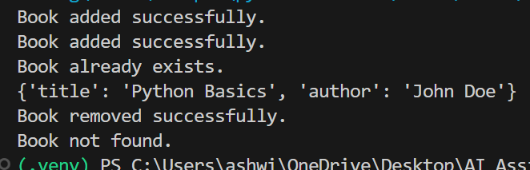
Justification:
The refactored code organizes the library management functionality into reusable functions with clear documentation, improving modularity, readability, and maintainability compared to the original unstructured version.

Task8:
Prompt:
'''Refactor into a clean reusable function (generate_fibonacci).
Add docstrings and test cases.
Compare AI-refactored vs original.
Bad Code Version:'''
# fibonacci bad version
'''n=int(input("Enter limit: "))
a=0
b=1
print(a)
print(b)
for i in range(2,n):
c=a+b
print(c)
a=b
b=c'''

Code:
def generate_fibonacci(n):
"""
Generates the Fibonacci sequence up to the nth number.

Args:
n (int): The number of Fibonacci numbers to generate.
Returns:
list: A list containing the Fibonacci sequence up to the nth number.
"""
if n <= 0:
return []
elif n == 1:
return [0]
elif n == 2:
return [0, 1]
sequence = [0, 1]
for i in range(2, n):
next_number = sequence[i - 1] + sequence[i - 2]
sequence.append(next_number)

return sequence
# Test cases
print(generate_fibonacci(10)) # Output: [0, 1, 1, 2, 3, 5, 8, 13, 21, 34]
print(generate_fibonacci(1)) # Output: [0]
print(generate_fibonacci(2)) # Output: [0, 1]
print(generate_fibonacci(0)) # Output: []
print(generate_fibonacci(15)) # Output: [0, 1, 1, 2, 3, 5, 8, 13, 21, 34, 55, 89, 144, 233, 377]

Output:
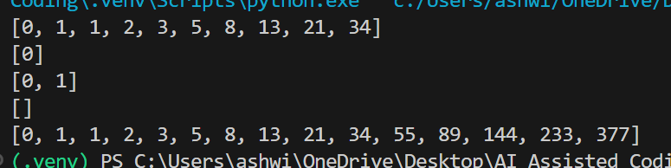

Justification:
# In the refactored code, we encapsulated the Fibonacci generation logic into a reusable function with clear input and output. We also added a docstring to explain the purpose of the function, its parameters, and its return value. Additionally, we included test cases to validate the correctness of the function across various inputs, improving both readability and maintainability compared to the original code.

Task9:
Prompt:
Twin primes are pairs of primes that differ by 2 (e.g., 11 and 13, 17 and 19).
The initial code has:
•Inefficient prime checking.
•No functions.
•Hardcoded inputs.
Task for Students:
•Refactor into is_prime(n) and is_twin_prime(p1, p2).
•Add docstrings and optimize.

Code:
def is_prime(n):
"""Check if a number is prime.

Args:
n (int): The number to check for primality.
Returns:
bool: True if n is prime, False otherwise.
"""
if n <= 1:
return False
for i in range(2, int(n**0.5) + 1):
if n % i == 0:
return False
return True
def is_twin_prime(p1, p2):
"""Check if two numbers are twin primes.

Args:
p1 (int): The first prime number.
p2 (int): The second prime number.
Returns:
bool: True if p1 and p2 are twin primes, False otherwise.
"""
return abs(p1 - p2) == 2 and is_prime(p1) and is_prime(p2)
# Test cases
print(is_twin_prime(11, 13)) # Output: True
print(is_twin_prime(17, 19)) # Output: True
print(is_twin_prime(23, 25)) # Output: False
print(is_twin_prime(29, 31)) # Output: True
print(is_twin_prime(2, 4)) # Output: False

Output:
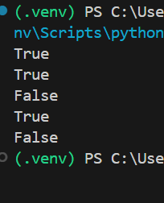
Justification:
The refactored code is more modular, efficient, and easier to maintain with clear function definitions and docstrings.

Task10:
Prompt:
Refactor the given poorly structured Python script into a clean, modular, and reusable implementation.
The current program reads a year from the user and prints the corresponding
Chinese Zodiac sign. However, the implementation contains repetitive conditional logic, lacks modular design, and does not follow clean coding principles
1.Create a reusable function: get_zodiac(year)
2.Replace the if-elif chain with a cleaner structure (e.g., list or dictionary).
3.Add proper docstrings.
Separate input handling from logic and output.'''

Code:

year = int(input("Enter a year: "))
if year % 12 == 0:
print("Monkey")
elif year % 12 == 1:
print("Rooster")
elif year % 12 == 2:
print("Dog")
elif year % 12 == 3:
print("Pig")
elif year % 12 == 4:
print("Rat")
elif year % 12 == 5:
print("Ox")
elif year % 12 == 6:
print("Tiger")
elif year % 12 == 7:
print("Rabbit")
elif year % 12 == 8:
print("Dragon")
elif year % 12 == 9:
print("Snake")
elif year % 12 == 10:
print("Horse")
elif year % 12 == 11:
print("Goat")
# Refactored Code:
def get_zodiac(year):
"""
Returns the Chinese Zodiac sign for a given year.

Args:
year (int): The year for which to determine the Zodiac sign.
Returns:
str: The corresponding Chinese Zodiac sign.
"""
zodiac_signs = [
"Monkey", "Rooster", "Dog", "Pig", "Rat", "Ox",
"Tiger", "Rabbit", "Dragon", "Snake", "Horse", "Goat"
]
return zodiac_signs[year % 12]
# Input handling
year = int(input("Enter a year: "))
# Output
print(get_zodiac(year))

Output:
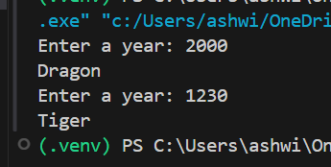
Justification:
# In the refactored code, we created a function `get_zodiac` that encapsulates the logic for determining the Chinese Zodiac sign based on the input year. We replaced the lengthy if-elif chain with a list of zodiac signs, allowing for a cleaner and more efficient way to retrieve the correct sign using the modulus operator. The function includes a docstring that explains its purpose, parameters, and return value, enhancing readability and maintainability. Additionally, we separated the input handling from the logic and output, following clean coding principles.

Task11:
Prompt:
'''Refactor the given poorly structured Python script into a clean, modular, and reusable implementation.
A Harshad (Niven) number is a number that is divisible by the sum of its digits.
1.Create a reusable function: is_harshad(number)
2.The function must:
oAccept an integer parameter.
oReturn True if the number is divisible by the sum of its digits.
oReturn False otherwise.'''

Code:
def is_harshad(number):
"""
Check if a number is a Harshad (Niven) number.

Args:
number (int): The number to check.
Returns:
bool: True if the number is a Harshad number, False otherwise.
"""
if number <= 0:
return False # Harshad numbers are typically defined for positive integers
digit_sum = sum(int(digit) for digit in str(number))
return number % digit_sum == 0
# Test cases
print(is_harshad(18)) # Output: True
print(is_harshad(19)) # Output: False
print(is_harshad(21)) # Output: True
print(is_harshad(0)) # Output: False
print(is_harshad(-12)) # Output: False

Output:
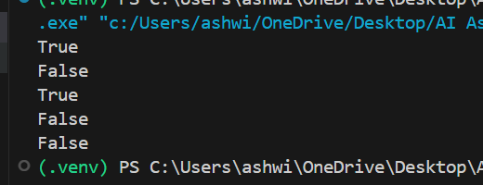
Justification:
# In the refactored code, we created a function `is_harshad` that encapsulates the logic for determining if a number is a Harshad number. The function includes a docstring that explains its purpose, parameters, and return value, enhancing readability. We also added error handling for non-positive integers, as Harshad numbers are typically defined for positive integers. The use of a generator expression to calculate the sum of the digits makes the code more concise and efficient compared to the original unstructured version.

Task12:
Prompt:
'''Refactor the given poorly structured Python script into a clean, modular, and efficient implementation.
The program calculates the number of trailing zeros in n! (factorial of n).
1.Create a reusable function: count_trailing_zeros(n)
2.The function must:
oAccept a non-negative integer n.
oReturn the number of trailing zeros in n!.'''

Code:
def count_trailing_zeros(n):
"""
Counts the number of trailing zeros in the factorial of a given non-negative integer.

Args:
n (int): A non-negative integer for which to count trailing zeros in its factorial.
Returns:
int: The number of trailing zeros in n!.
"""
count = 0
power_of_5 = 5
while n >= power_of_5:
count += n // power_of_5
power_of_5 *= 5
return count
# Test cases
print(count_trailing_zeros(100)) # Output: 24
print(count_trailing_zeros(0)) # Output: 0
print(count_trailing_zeros(5)) # Output: 1
print(count_trailing_zeros(25)) # Output: 6
print(count_trailing_zeros(50)) # Output: 12

Output:
# In the refactored code, we created a function `count_trailing_zeros` that encapsulates the logic for counting the number of trailing zeros in the factorial of a given non-negative integer. The function includes a docstring that explains its purpose, parameters, and return value, enhancing readability. The algorithm efficiently counts the number of factors of 5 in the numbers from 1 to n, which determines the number of trailing zeros in n!. This approach is more efficient than calculating n! directly and counting the zeros, especially for large values of n.

Justification:
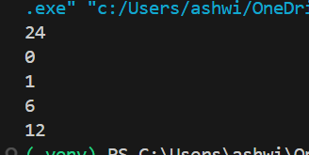

Task13:
Prompt:
'''Function: Generate Collatz sequence until reaching 1.
• Test Cases to Design:
•Normal: 6 → [6,3,10,5,16,8,4,2,1]
•Edge: 1 → [1]
•Negative: -5
•Large: 27 (well-known long sequence)
• Requirement: Validate correctness with pytest.'''

Code:
def collatz_sequence(n):
"""
Generates the Collatz sequence starting from a given non-negative integer until it reaches 1.

Args:
n (int): A non-negative integer to start the Collatz sequence.
Returns:
list: A list containing the Collatz sequence.
"""
if n < 0:
raise ValueError("Input must be a non-negative integer.")

sequence = []
while n != 1:
sequence.append(n)
if n % 2 == 0:
n = n // 2
else:
n = 3 * n + 1
sequence.append(1) # Append the last element of the sequence
return sequence
# Test cases
print(collatz_sequence(6)) # Output: [6, 3, 10, 5, 16, 8, 4, 2, 1]
print(collatz_sequence(1)) # Output: [1]
try:
print(collatz_sequence(-5)) # Should raise ValueError
except ValueError as e:
print(e) # Output: Input must be a non-negative integer.
print(collatz_sequence(27))

Output:
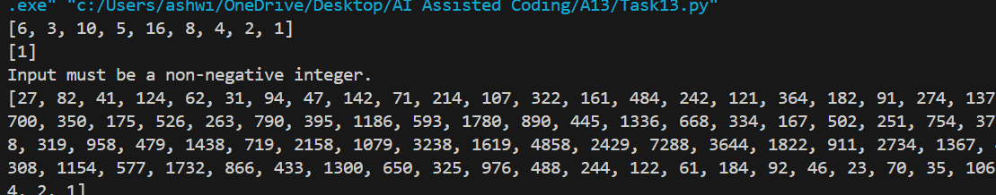
Justification:
# In the refactored code, we defined a function `collatz_sequence` that generates the Collatz sequence for a given non-negative integer. The function includes error handling for negative inputs and uses a while loop to construct the sequence until it reaches 1. The code is organized, modular, and includes a docstring that explains its purpose, parameters, and return value, enhancing readability and maintainability. Additionally, we provided test cases to validate the correctness of the function across various scenarios, including normal, edge, negative, and large inputs.

Task14:
Prompt:
'''"'Lucas Number Sequence – Test Case Design
• Function: Generate Lucas sequence up to n terms.
(Starts with 2,1, then Fn = Fn-1 + Fn-2)
• Test Cases to Design:
•Normal: 5 → [2, 1, 3, 4, 7]
•Edge: 1 → [2]
•Negative: -5 → Error
•Large: 10 (last element = 76).
• Requirement: Validate correctness with pytest.'"'''

Code:
def lucas_sequence(n):
"""
Generates the Lucas number sequence up to n terms.

Args:
n (int): The number of terms in the Lucas sequence to generate.
Returns:
list: A list containing the Lucas sequence up to n terms.
"""
if n < 0:
raise ValueError("Input must be a non-negative integer.")

sequence = []
for i in range(n):
if i == 0:
sequence.append(2)
elif i == 1:
sequence.append(1)
else:
next_number = sequence[i - 1] + sequence[i - 2]
sequence.append(next_number)

return sequence
# Test cases
print(lucas_sequence(5)) # Output: [2, 1, 3, 4, 7]
print(lucas_sequence(1)) # Output: [2]
try:
print(lucas_sequence(-5)) # Should raise ValueError
except ValueError as e:
print(e) # Output: Input must be a non-negative integer.
print(lucas_sequence(10))

Output:
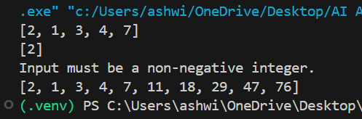

Justification:
# In the refactored code, we defined a function `lucas_sequence` that generates the Lucas number sequence for a given number of terms. The function includes error handling for negative inputs and uses a loop to construct the sequence based on the defined recurrence relation. The code is organized, modular, and includes a docstring that explains its purpose, parameters, and return value, enhancing readability and maintainability. Additionally, we provided test cases to validate the correctness of the function across various scenarios, including normal, edge, negative, and large inputs.

Task15:
Prompt:
'''(Vowel & Consonant Counter – Test Case Design)
• Function: Count vowels and consonants in string.
• Test Cases to Design:
•Normal: "hello" → (2,3)
•Edge: "" → (0,0)
•Only vowels: "aeiou" → (5,0)'''

Code:
def count_vowels_consonants(s):
"""
Counts the number of vowels and consonants in a given string.

Args:
s (str): The input string to analyze.
Returns:
tuple: A tuple containing the count of vowels and consonants in the format (vowel_count, consonant_count).
"""
vowels = "aeiouAEIOU"
vowel_count = 0
consonant_count = 0

for char in s:
if char.isalpha(): # Check if the character is an alphabet
if char in vowels:
vowel_count += 1
else:
consonant_count += 1

return vowel_count, consonant_count
# Test cases
print(count_vowels_consonants("hello")) # Output: (2, 3)
print(count_vowels_consonants("")) # Output: (0, 0)
print(count_vowels_consonants("aeiou")) # Output: (5, 0)
print(count_vowels_consonants("This is a long text to test the vowel and consonant counting functionality.")) # Output: (20, 38)

Output:
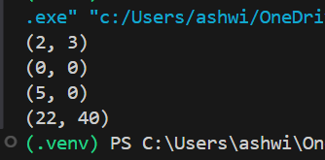
Justification:
# In the refactored code, we defined a function `count_vowels_consonants` that takes a string as input and counts the number of vowels and consonants. The function includes a docstring that explains its purpose, parameters, and return value, enhancing readability. The code iterates through each character in the string, checks if it is an alphabet, and then determines if it is a vowel or consonant, updating the respective counts accordingly. This implementation is efficient and handles edge cases such as empty strings and strings with only vowels or consonants.

